Shri Shamrao Patil (Yadravkar) Educational & Charitable Trust’s
SHARAD INSTITUTE OF TECHNOLOGY
POLYTECHNIC, YADRAV.

DEPARTMENT OF INFORMATION TECHNOLOGY
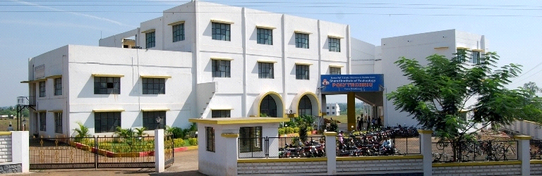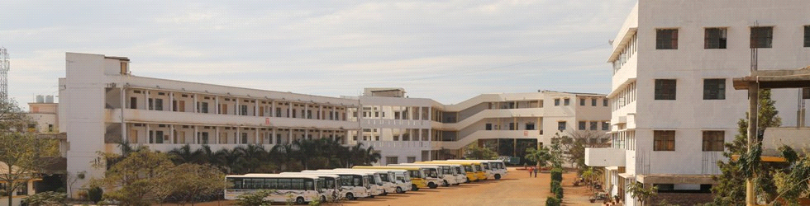
MICRO PROJECT REPORT
IN
GUI Application Development Using VB.net
FOR
2019-20

Part a Plan
Micro Project Report

Title of micro project :- Library Management System using VB.net.
Brief introduction :-
The proposed project titled “Library Management” is a desktop application to organize the working of a school library. A library may contain thousands and thousands of books; it becomes a tedious process to keep track of all the book flow from time to time. There will be an option to enter books subject wise with other details such as author, edition etc. All the student details are entered with their respective role no: Issue and return of books are noted correctly and entered into the software.
The fines paid by the students are also recorded correctly. This software would be very helpful for a librarian or whoever manages the library. A search option would be provided in books and student entry form for easy use.

Importance of project:
- Libraries dole out a critical role in the Education industry.
- It is considered as the brain of any education institute, be it small or large schools,colleges or universities.
- Today education institutes understand the importance of the library with the increase in education standards.
- With the development of digital content, it becomes more important to manage the catalog of educational information with a scalable and reliable Library Management System that will support the general requirement of the library.
- Easy to use Campus library management systems are now available for stress-free management of campus libraries of any size.
- A trustworthy web-based library management system provides a complete resolution for students, librarians, and faculty members.

Aim /Benefits of the micro-project:-
To get the knowledge of different controls in VB.net .
To collect videos for how to create forms and attach database to the project.
To get information about new functions and controls require for our coding.
To study about that SQL database and also new header lines.

Course outcome :-
- Use Visual Studio IDE to design application.
- Develop GUI Application using Form Controls and its events.
- Use Data Access Control to store data in database and retrieve it.

Skill Development :-
- Due to this project we are able to implement the GUI based Applications
- Due to this project we are able to attach the databases to the project based on GUI.
- Due to this project we are able to design the application .

Action plan:-
Sr. no | Activity | Planned start  date | Planned finish  date | Name of responsible  team member
1) | .  First we form our groups. |  |  | 1)Shweta Deepak Bhosale  2)Shreya Shrimandhar Demapure  3)Shabdali Suresh Shetty
2) | Then we suggest the project names to our project guide. |  |  | 1)Shweta Deepak Bhosale  2)Shreya Shrimandhar Demapure  3)Shabdali Suresh Shetty
3) | Then our mam gives us project name as Library Management System in VB.net. |  |  | 1)Shweta Deepak Bhosale.  2)Shreya Shrimandhar Demapure  3)Shabdali Suresh Shetty
4) | Then we will search information about coding of library management System in VB.net. |  |  | 1)Shweta Deepak Bhosale  2)Shreya Shrimandhar Demapure  3)Shabdali Suresh Shetty
5) | After searching the information we will download the software visual studio 2012 |  |  | 1)Shweta Deepak Bhosale  2)Shreya Shrimandhar Demapure  3)Shabdali Suresh Shetty
6) | After that we will sure that our information is true or false from our project guide. |  |  | 1)Shweta Deepak Bhosale  2)Shreya Shrimandhar Demapure  3)Shabdali Suresh Shetty
7) | Then we will start to create our project . Also we will get information about new controls which we will use in our project. |  |  | 1)Shweta Deepak Bhosale  2)Shreya Shrimandhar  Demapure  3)Shabdali Suresh Shetty
8) | And then we will download the videos which are related to project. |  |  | 1) Shweta Deepak Bhosale  2)Shreya Shrimandhar  Demapure  3)Shabdali Suresh Shetty
9) | Then we will study about new controls and new header lines which we will use during project. |  |  | 1)Shweta Deepak Bhosale  2)Shreya Shimandhar Demapure  3)Shabdali Suresh Shetty
10) | And again we will show this information to our project guide. |  |  | 1)Shweta Deepak Bhosale.  2)Shreya Shrimandhar Demapure  3)Shabdali Suresh Shetty
11) | Then we will show those video. |  |  | 1)Shweta Deepak Bhosale  2)Shreya Shrimandhar Demapure  3)Shabdali Suresh Shetty
12) | Then finally we will start to create our forms. |  |  | 1)Shweta Deepak Bhosale  2)Shreya Shrimandhar  Demapure  3)Shabdali Suresh Shetty
13) | After that we will distribute the project work in group members. Then we will create temporary form and then we will connect the database. |  |  | 1)Shweta Deepak Bhosale  2)Shreya Shrimandhar  Demapure  3)Shabdali Suresh Shetty
14) | After that we will show the temporary forms coding of our project to our guide & take some suggestions. |  |  | 1)Shweta Deepak Bhosale  2 )Shreya Shrimandhar Demapure  3)Shabdali Suresh Shetty
15) | Then after give some suggestions we will create our final coding using Visual Studio 2012 software. |  |  | 1)Shweta Deepak Bhosale  2)Shreya Shrimandhar Demapure  3)Shabdali Suresh Shetty
16) | And then submit our project to our project guided. |  |  | 1) Shweta Deepak Bhosale  2)Shreya Shrimandhar Demapure  3)Shabdali Suresh Shetty

- Resource required :
Sr no | Name of recourses | Specification | Quantity | Remark
1) | Computer system | Windows 7 ultimate | 4 | It is used to  Create report & proposal
2) | Software | Visual Studio 2012 | 4 | It is used to  Create coding of project
2) | Browser | https://en.wikipedia.org/wiki/Library management System in VB.net/ | _ | It is used to search the information

- Name of Student :- Roll No

- Shweta Deepak Bhosale. 12504

- Shreya Shrimandhar Demapure. 12507

- Shabdali Suresh Shetty 12521

